**Does Weather impact Food sales?**

**Discussion:**

Farming and fisheries are exceedingly reliant on the atmosphere. Increments in temperature and carbon dioxide can build some product yields in a few spots. Be that as it may, to understand these advantages, supplement levels, soil dampness, water accessibility, and different conditions should likewise be met. Changes in the recurrence and seriousness of dry seasons and surges could posture challenges for agriculturists and farmers and debilitate nourishment security. Then, hotter water temperatures are probably going to bring about the living space scopes of many fish and shellfish species to move, which could upset biological communities. In general, environmental change could make it more hard to develop crops, raise creatures, and catch angle in an indistinguishable ways and same spots from we have done before. The impacts of environmental change additionally should be considered alongside other developing elements that influence rural generation, for example, changes in cultivating practices and innovation.

* Higher CO2 levels can affect crop yields. Some laboratory experiments suggest that elevated CO2 levels can increase plant growth.  However, other factors, such as changing temperatures, ozone, and water and nutrient constraints, may counteract these potential increases in yield.
* More extreme temperature and precipitation can prevent crops from growing. Extreme events, especially floods and droughts, can harm crops and reduce yields.
* Dealing with drought could become a challenge in areas where rising summer temperatures cause soils to become drier. Although increased irrigation might be possible in some places, in other places water supplies may also be reduced, leaving less water available for irrigation when more is needed.
* Many weeds, pests, and fungi thrive under warmer temperatures, wetter climates, and increased CO2 levels. The ranges and distribution of weeds and pests are likely to increase with climate change. This could cause new problems for farmers' crops previously unexposed to these species.
* Though rising CO2 can stimulate plant growth, it also reduces the nutritional value of most food crops. Rising levels of atmospheric carbon dioxide reduce the concentrations of protein and essential minerals in most plant species, including wheat, soybeans, and rice. This direct effect of rising CO2 on the nutritional value of crops represents a potential threat to human health. Human health is also threatened by increased pesticide use due to increased pest pressures and reductions in the efficacy of pesticides.
* Many aquatic species can find colder areas of streams and lakes or move north along the coast or in the ocean.
* Some marine disease outbreaks have been linked with changing climate.
* Heat waves, which are projected to increase under climate change, could directly threaten livestock.
* Drought may threaten pasture and feed supplies. Drought reduces the amount of quality forage available to grazing livestock. Some areas could experience longer, more intense droughts, resulting from higher summer temperatures and reduced precipitation. For animals that rely on grain, changes in crop production due to drought could also become a problem.

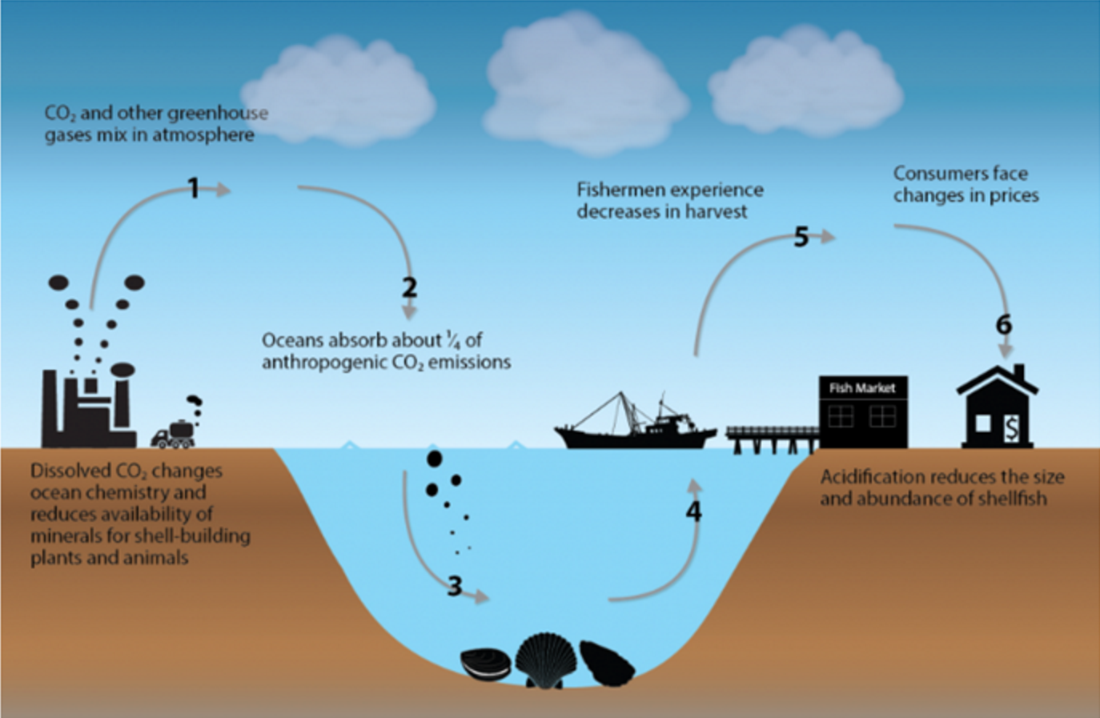

These impacts of environmental change on farming and sustenance supply are probably going to be like those found in the United States. However, other stressors such as population growth may magnify the effects of climate change on food security. In creating nations, adjustment choices like changes in yield administration or farming practices, or upgrades to water system are more restricted than in the United States and other industrialized countries.

Any atmosphere related unsettling influence to nourishment conveyance and transport, globally or locally, may have critical effects on wellbeing and quality as well as on sustenance get to. For instance, the nourishment transportation framework in the United States as often as possible moves extensive volumes of grain by water. On account of an extraordinary climate occasion influencing a conduit, there are few, assuming any, substitute pathways for transport. High temperatures and a lack of rain can prompted a standout amongst the most extreme summer dry spells the country has seen and postured genuine effects to the Mississippi River watershed, a noteworthy cross-country shipping course for Midwestern horticulture. This dry spell brought about noteworthy nourishment and monetary misfortunes because of decreases in flatboat activity, the volume of products conveyed, and the quantity of Americans utilized by the tugboat business. The 2012 dry season was promptly trailed by flooding all through the Mississippi in the spring of 2013, which additionally brought about disturbances of freight ship activity and nourishment transport. Transportation changes, for example, these diminish the capacity of ranchers to send out their grains to universal markets, and can influence worldwide sustenance costs. Impacts to the global food supply concern the United States because food shortages can cause humanitarian crises and national security concerns.  They also can increase domestic food prices.

**Conclusion:**

Environmental change is probably going to influence nourishment security at the worldwide, provincial, and nearby level. Climate change can disrupt food availability, reduce access to food, and affect food quality. For instance, anticipated increments in temperatures, changes in precipitation designs, changes in outrageous climate occasions, and decreases in water accessibility may all result in reduced agricultural productivity. Increments in the recurrence and seriousness outrageous climate occasions can likewise intrude on sustenance conveyance, and coming about spikes in nourishment costs after extraordinary occasions are relied upon to be more regular later on. Increasing temperatures can contribute to spoilage and contamination.

All the techniques are properly measured to assess climate and atmosphere extremes in atmosphere display recreations. The mix of atmosphere model with observational and reanalysis items requires creative examinations and measurements of execution that make utilization of data identified with procedures producing inside atmosphere changeability and opening up climate and atmosphere extremes.

The results from the below methods shows the correlation between every variables and its sizeable impact on the food sales. The key variables identified by performing various techniques and the graphs below identifies the correlation between them.